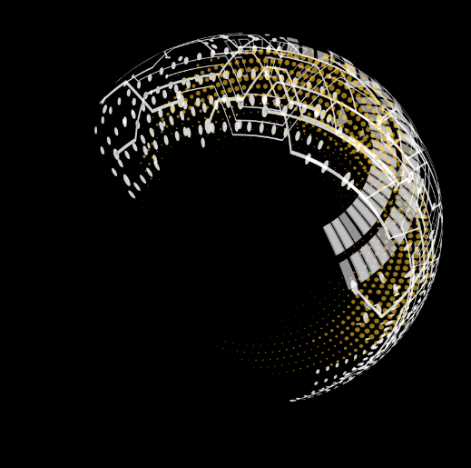

**Detail Design Document**

**Salesforce India Dealer Portal -**

**Subdealers APIs**



**Version: 1.0**

**Author: Tanushree Deshpande & Aman Singh**

**Date: 10-Nov-2020**

Version: 1.0

Date: 31/12/2019

Author: Suraj Desai

Table of Contents

Revision Log 1

Introduction 2

System Overview 2

API Details 3

Subdealer Registration API: (Experience Layer) 3

Technologies 5

Environments 5

Deployment Strategy 5

APIM Details 5

APIM Policies 6

Security 6

Logging Methods 7

# Revision Log

|  |  |  |  |
| --- | --- | --- | --- |
| **Date** | **Author** | **Version** | **Changes** |
| 27- October-2020 | Tanushree Deshpande | 1.0 | Initial Draft |
| 19- November-2020 | Aman Singh | 1.0 | APIM Details |

# 

# Introduction

Sub-Dealers are the customers who don’t have direct financial relationship with Michelin. Those are also called as Indirect customers of Michelin. There are two type of sub-dealers available in Michelin as below

* **Michelin Sub-dealers (normally dealers)** –There are nothing but dealers but sometime there are use cases where dealer need to buy a smaller number of tires in that case Michelin suggest buying it from distributors. This sales transaction will be out of system. *They can also do direct business with Michelin as well via dealer portal.*
* **Non-Michelin Sub dealers** -Always do the business with specific distributors(dealers). The relationship between sub-dealer and direct customer is required.

## System Overview

1. Subdealer details onboarding will be done in Swagat Portal, further subdealer’s Account details and Commercial link will be registered in salesforce using real time **Subdealer Registration API**.
2. The account will be synced with MDM in real time and MDM Id will be updated against site record in salesforce.
3. **MDM details API** will update the MDM ID back against the sub dealer record into Swagat Portal to in sync registration of Subdealers.
4. **Integration of Swagat Portal & Salesforce done in DellBoomi Integration Platform.**
5. **Data flow** among Swagat, Salesforce, MDM and Dell Boomi Platformpresented as below**:**

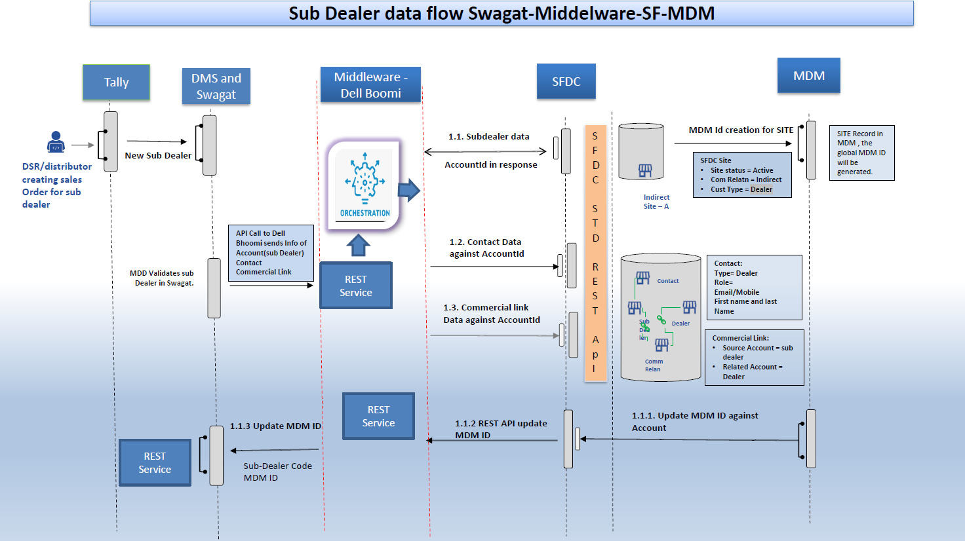

Fig. Data Flow Diagram

# 

# API Details

API-Led connectivity will be established using more than one layer of APIs. The Top layer, also known as the **Experience API layer**, will encompass APIs that are built for specific purpose. These are built for a specific business or technical use case or mode of interaction. Example – Swagat Portal.  
The bottom layer, also known as the **System APIs**, is composed of only one API. This is an API which provides connectivity to the underlying system of record, which in this case is Salesforce APIs.



## Subdealer Registration API: (Experience Layer)

This is an API for Subdealer Registration utilized by Swagat Portal to register Subdealer's information in Salesforce. Subdealer’s information includes registration of Accounts details, Contact details and Commercial Link information in Salesforce Cloud.

#### **Sequence Diagram:**



#### **Http Method:** POST

#### **Http Method:** https://api.michelingroup.com/sf-swagatportal/subDealer

#### **Request Headers:**

OAuth 2.0 & API Key validation is to validate call is coming from Swagat Portal.

|  |  |
| --- | --- |
| **Parameters** | **Value (Default)** |
| x-Gateway-APIKey | 8444b5e8-38af-4323-b415-ed7d407c7305 |
| Accept | application/json |
| Content-Type | application/json |
| Authorization | 8444b5e8-38af-4323-b415-ed7d407c7305 |

#### **Request Body** **Structure**:

**{**

**"accountDetails": {**

**"subDealername": "string",**

**"businessUnit": "PC",**

**"dealerStatus": "Yes",**

**"shippingAddress": {**

**"shippingCity": "string",**

**"shippingStreet": "string",**

**"shippingCountry": "string"**

**},**

**"TaxIdentificationNumber": "string",**

**"distributorName": "string",**

**"subdealerMobile": 0,**

**"subdealerCode": "string",**

**"AMGroundId": {**

**"PLGroundCode": "string",**

**"TCGroundCode": "string",**

**"2WGroundCode": "string",**

**"GCGroundCode": "string"**

**}**

**},**

**"contactDetails": {**

**"firstName": "string",**

**"lastName": "string",**

**"email": "string",**

**"mobile": 0**

**},**

**"commercialLinkDetails": {**

**"shipToCode": "string",**

**"dealerCode": "string"**

**}**

**}**

#### 

#### **Response Body**:

**{**

**"code": 201,**

**"message": "Subdealer Registered Successfully"**

**}**

#### **Response Codes**:

|  |  |
| --- | --- |
| **Status Code** | **Description** |
| 201 | Created |
| 400 | Bad Request /DUPLICATES_DETECTED from SF |
| 401 | Unauthorized |
| 405 | Method not Allowed |
| 500 | Internal Server Error |

Technologies

Restful APIs will be designed in **DellBoomi Platform (IPaaS)** using Integration process flow.

Environments

Dev,QA, PreProd/Indus, Prod

## Deployment Strategy

*D*eployment will be done in Dell Boomi Cloud using boomi Atom workers. Manual/ Scheduled deployment is possible as per requirement.

## APIM Details

**API Proxy / Target details:**

API Name: swagatportal-subdealer

|  |  |
| --- | --- |
| SAG Env. | Software AG endpoints URL’s |
| DEV | <https://dev.api.michelingroup.com/gateway/swagatportal-subdealer/v1/subDealer>  [https://dev.api.michelingroup.com/gateway/swagatportal-subdealer/v1/subDealer/mdm/{subDealerCode}](https://dev.api.michelingroup.com/gateway/swagatportal-subdealer/v1/subDealer/mdm/%7bsubDealerCode%7d) |
| QUALIF | <https://test.api.michelingroup.com/gateway/swagatportal-subdealer/v1//subDealer>  [https://test.api.michelingroup.com/gateway/swagatportal-subdealer/v1/subDealer/mdm/{subDealerCode}](https://test.api.michelingroup.com/gateway/swagatportal-subdealer/v1/subDealer/mdm/%7bsubDealerCode%7d) |
| INDUS | <https://indus.api.michelingroup.com/gateway/swagatportal-subdealer/v1/subDealer>  [https://indus.api.michelingroup.com/gateway/swagatportal-subdealer/v1/subDealer/mdm/{subDealerCode}](https://indus.api.michelingroup.com/gateway/sf-swagatportal/v1/subDealer/mdm/%7bsubDealerCode%7d) |
| PROD | <https://api.michelingroup.com/gateway/swagatportal-subdealer/v1/subDealer>  [https://api.michelingroup.com/gateway/swagatportal-subdealer/v1/subDealer/mdm/{subDealerCode}](https://api.michelingroup.com/gateway/swagatportal-subdealer/v1/subDealer/mdm/%7bsubDealerCode%7d) |

|  |  |  |
| --- | --- | --- |
| Native Env. | Native Endpoint URL’s | Alias |
| DEV | TBD | dev-sf-swagatportal-https-endpoint |
| TEST | TBD | test- sf-swagatportal -https-endpoint |
| PROD | TBD | sf-swagatportal-https-endpoint |

APIM Policies

## Transport

|  |  |
| --- | --- |
| Requirement | Implemented(Y) |
| Enable HTTP / HTTPS | Y |

## Identify & Access

|  |  |
| --- | --- |
| Requirement | Implemented(Y) |
| **Identify & Authorize Application** | Y |

## Routing

|  |  |
| --- | --- |
| Requirement | Implemented(Y) |
| **Straight Through Routing** | Y |

## Traffic Monitoring

|  |  |
| --- | --- |
| Requirement | Implemented(Y) |
| Log Invocation | Y |

## Error Handling

|  |  |
| --- | --- |
| Requirement | Implemented(Y) |
| Conditional Error Processing | Y |

## Security

The purpose of APIs is to connect services and transfer data, hence data flow among multiple systems needs to be secure. In Salesforce- Swagat Integration we will use below authentication methods:

## 

## **Security Requirements – Client Side**

## Transport Security

One Way SSL.

## API-Key

X-Gateway-APIKey

## Oauth 2.0

Authorization Header

# **Security Requirements – Target Side**

## Transport Security

Basic Authentication

Logging Methods

DellBoomi process logs are available in Process reporting, along with that Splunk integration can be done to monitor logs between different systems.